The Standing Order Module:

User Requirements:

* Customers must have an account created for them
* Customer must be able to create a new standing order
* Customer must be able to add and change their current standing order
* Customer must be able to view their current standing order

System Requirements:

* System should be able to authenticate the customer
* System should provide the customer with the option to create a new standing order
* System should allow the customer to modify their current standing order
* System should allow the customer to view their current standing order.

GENERATE MONTHLY STANDING ORDER FOR A CUSTOMER

|  |  |  |
| --- | --- | --- |
| REQUIREMENTS: | MONTHLY STANDING ORDER FOR CUSTOMER | |
| USE CASE NAME: | STANDING ORDER INVENTORY | |
| RELATED REQUIREMENTS: | RECIEVABLES, INVOICES AND STANDING ORDER ID. | |
| GOAL IN CONTEXT: | THE USER MUST BE ABLE TO CHECK ALL STANDING ORDERS ON A PARTICULAR MONTH FOR A CUSTOMER | |
| PRECONDITIONS: | THE DATABASE MUST BE UPDATED WITH ALL INFORMATION, THE USER MUST HAVE ACCESS TO THE APPLICATION. | |
| SUCCESSFUL END CONDITION: | MONTHLY STANDING ORDER REPORT WAS GENERATED. | |
| FAIL END CONDITION: | MONTHLY STANDING ORDER REPORT WAS NOT GENERATED. | |
| PRIMARY ACTORS: | EMPLOYEE | |
| SECONDARY ACTORS: | BOSS | |
| TRIGGER: | - | |
| MAIN FLOW: | STEP 1 | EMPLOYEE LOGS ON THE APPLICATION WITH THEIR PASSWORD |
| STEP 2 | EMPLOYEE ACCESSES THE STANDING ORDER DATABASE. |
| STEP 3 | EMPLOYEE THEN ACCESSES DATA FROM THE RECIEVABLES AND INVOICES DATABASE. |
| STEP 4 | BASED ON THE DATA RECORDED IN DATABASE THE EMPLOYEE THEN TALLIES ALL THE STANDING ORDER FOR THE REQUIRED MONTH. |
| STEP 5 | A MONTHLY REPORT IS GENERATED. |
|
|

|  |  |  |
| --- | --- | --- |
| REQUIREMENTS: | MONTHLY INVOICES FOR CUSTOMER | |
| USE CASE NAME: | INVOICES INVENTORY | |
| RELATED REQUIREMENTS: | INVOICES FOR CUSTOMER AND RECIEVABLES. | |
| GOAL IN CONTEXT: | THE USER MUST BE ABLE TO TALLY MONTHLY INVOICES FOR A CUSTOMER | |
| PRECONDITIONS: | THE USER MUST HAVE ACCESS TO THE APPLICATION. | |
| SUCCESSFUL END CONDITION: | MONTHLY INVOICE REPORT WAS GENERATED. | |
| FAIL END CONDITION: | MONTHLY INVOICE REPORT WAS NOT GENERATED. | |
| PRIMARY ACTORS: | EMPLOYEE | |
| SECONDARY ACTORS: | BOSS AND CUSTOMER | |
| TRIGGER: | - | |
| MAIN FLOW: | STEP 1 | EMPLOYEE LOGS ON THE APPLICATION WITH THEIR PASSWORD |
| STEP 2 | EMPLOYEE ACCESSES THE INVOICE DATABASE. |
| STEP 3 | EMPLOYEE THEN ACCESSES DATA FROM THE RECIEVABLES AND INVOICES DATABASE. |
| STEP 4 | BASED ON THE DATA RECORDED IN DATABASE THE EMPLOYEE THEN TALLIES ALL THE INVOICES FOR THE REQUIRED MONTH. |
| STEP 5 | A MONTHLY REPORT IS GENERATED. |
|
|

GENERATE MONTHLY INVOICES FOR A PARTICULAR CUSTOMER

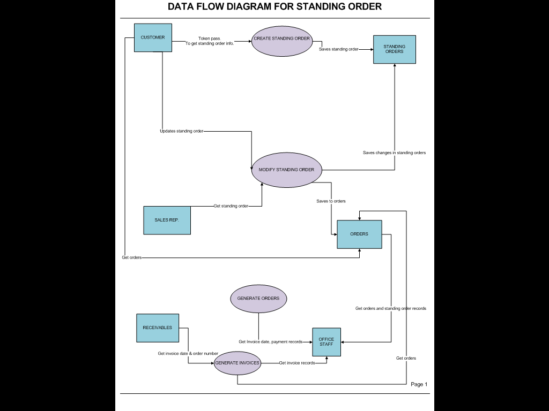

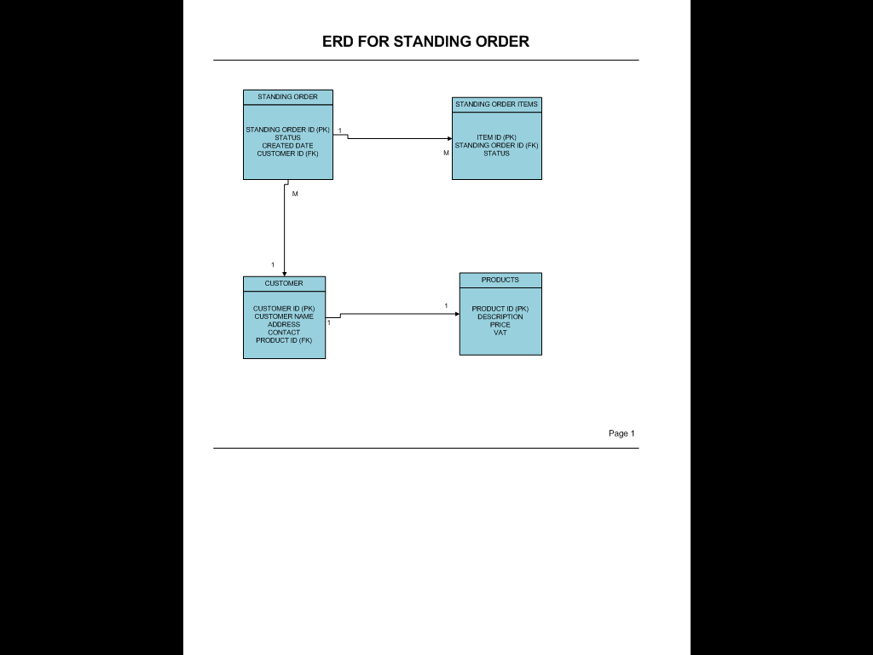

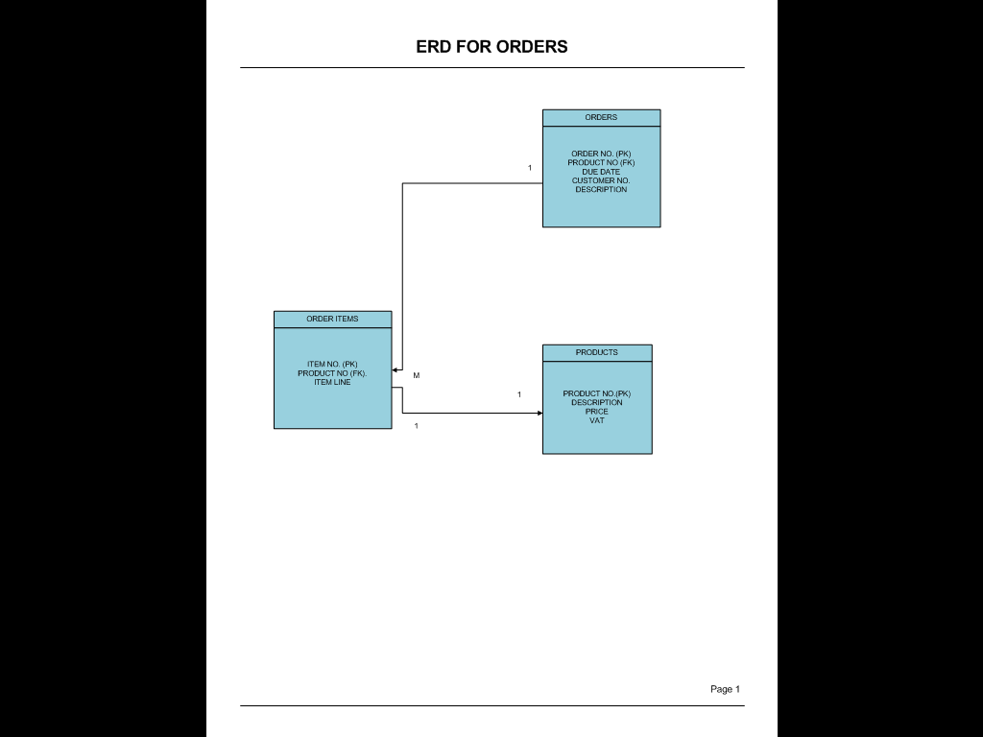

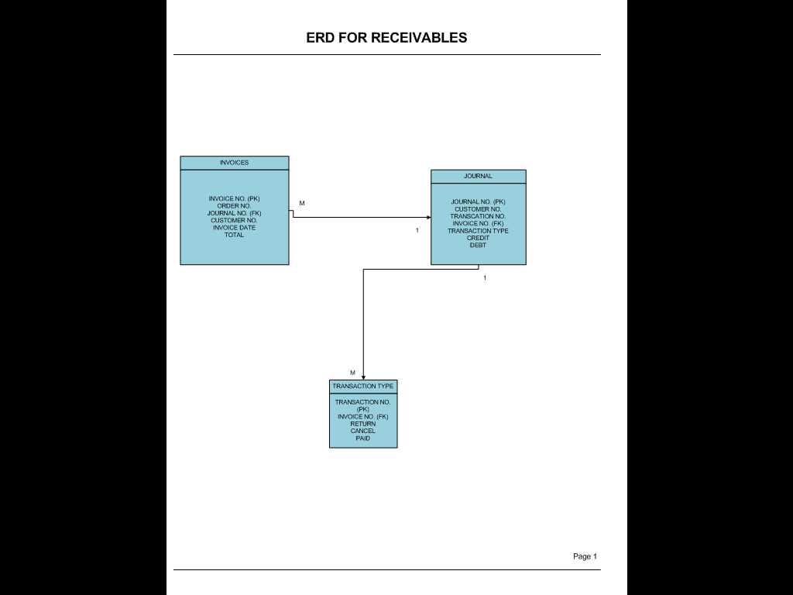

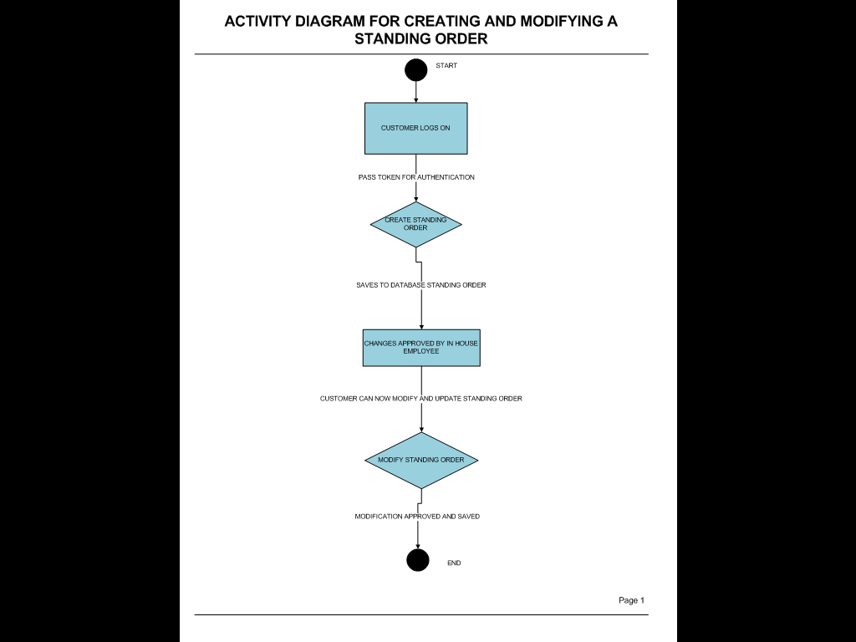

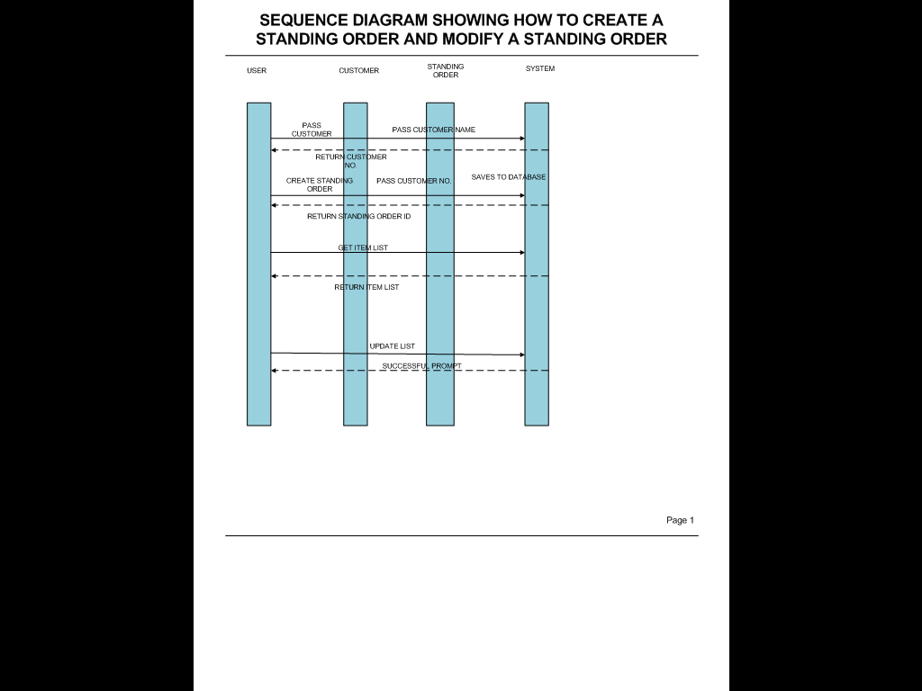

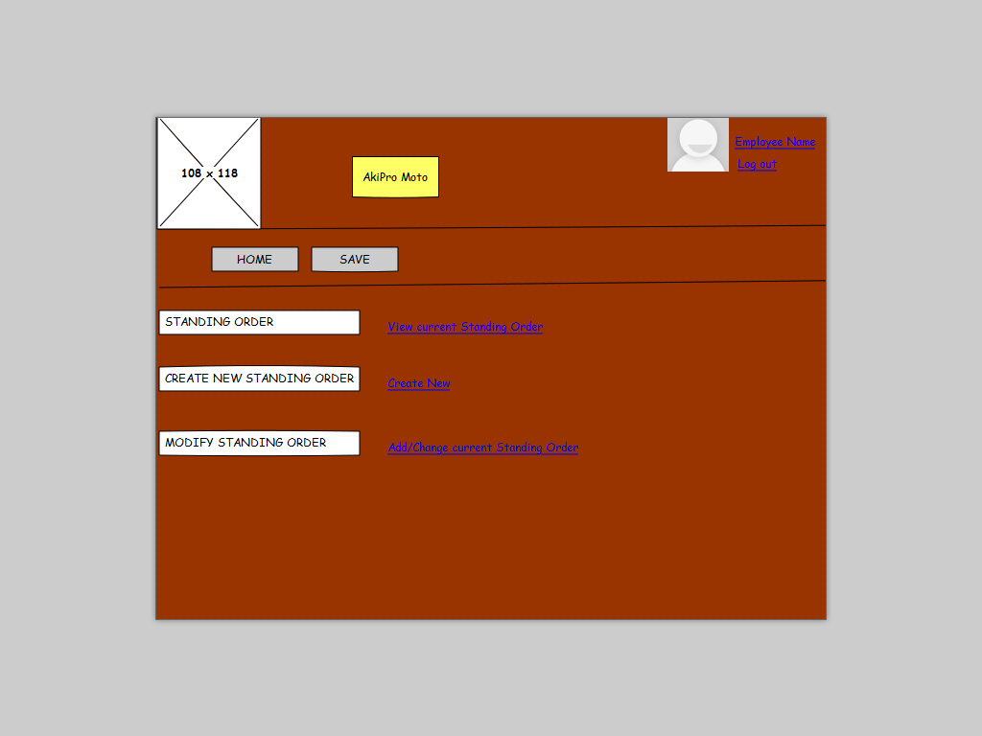

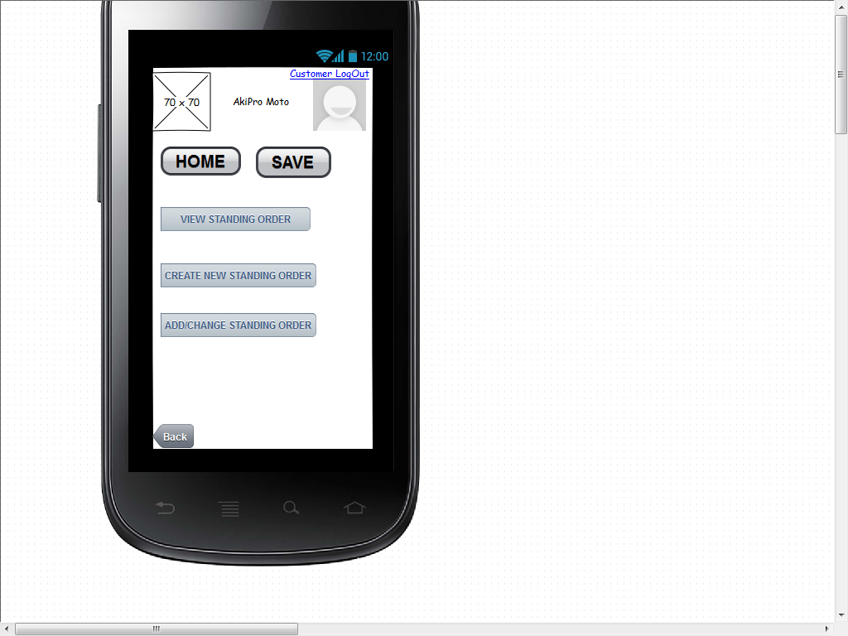

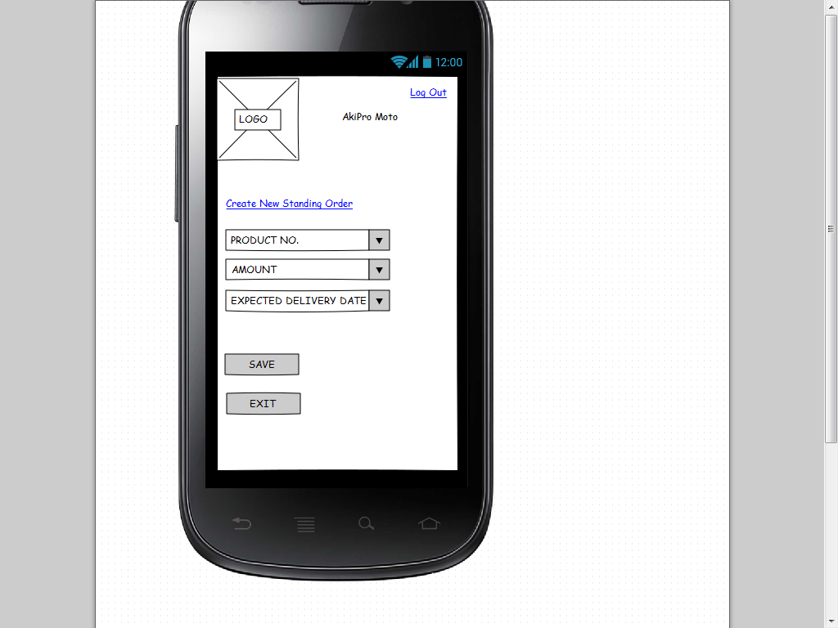

**Resource Diagrams:**

Resource Diagram: Standing Order

|  |  |  |  |
| --- | --- | --- | --- |
| Action | Input Parameter | Output | Description |
| Get | Customer No., Standing Order No. | Customer No., Standing Order No. Product No., Description | A list of items which is selected for a standing order is displayed. |
| Post | Operation, Token | A JSON object with a string to show the status of the request | Operation can be equal to displaying a list of items selected for a standing order. |
| Put | Customer No., Standing Order No., Product No., Description, Delivery due day | A JSON object with a string to the show the status of the request | Standing Order is created and saved to the Database. |
| Delete | Standing Order No. | A JSON object with a string to show the status of the request. | Delete all. |